NOMAD SOP
Background:
NOMAD (Novel Materials Discovery) is a materials database that allows materials data to be shared within the group and to the wider scientific community. Once uploaded, your materials data is parsed into standardised labels and can be easily queried and accessed. The package includes a web based browser for easier searchability. Uploads are private by default, when your data is uploaded to NOMAD nothing is published until you choose to do so. However, once an upload is published it can never be removed, and its metadata cannot be edited.
Process:
Step 1: (First time use only)
Begin by following this link [https://nomad-lab.eu/prod/v1/gui/search/entries] which brings you to the NOMAD web interface. Click ‘LOGIN/REGISTER’ in the top right-hand corner.

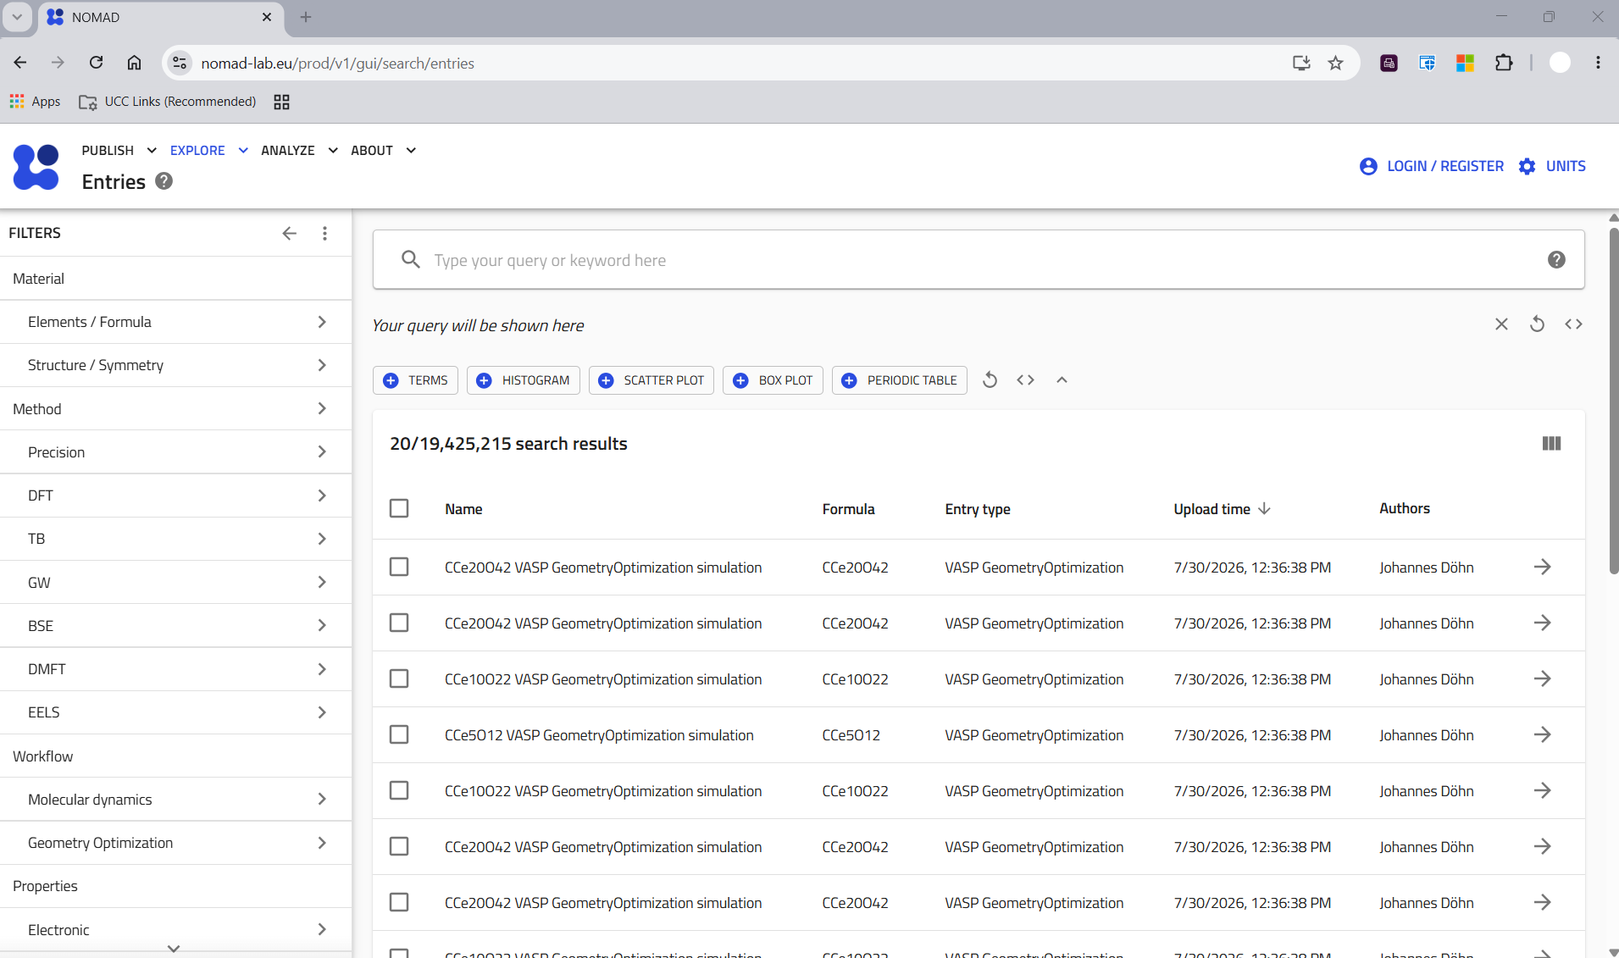
You can choose to register with your email alone or select “Sign in with Institutional Account”. Type “Cork” in the search bar and UCC will come up. You can alternatively type “ORCID” or “GitHub” in the search bar and sign in with your GitHub or OrcidID.
If you log into NOMAD via different accounts, your NOMAD accounts (and thus your database) can be linked together by typing in your username after sign in.

Option A (Manual Upload):
Once you have signed up and logged in (login page reachable via the link in step 2) you will land again on the NOMAD web interface homepage. Data can be uploaded directly to NOMAD via the command line. Hover over publish in the top left hand corner, then click uploads, to arrive at the upload page.
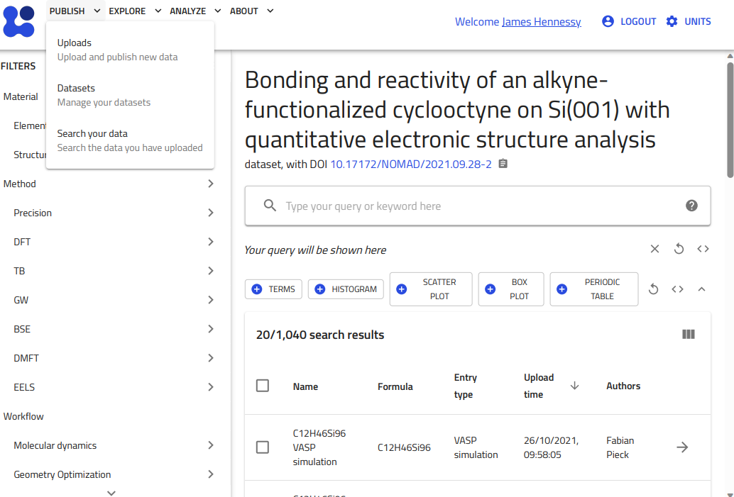
You have the option to upload files directly to the web interface or to send a file archive via a shell command. The latter is easier when uploading files directly from a HPC cluster.
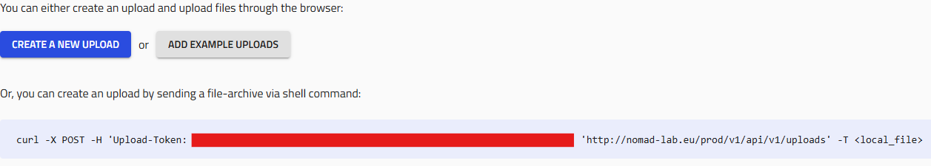
The web page (shown above) gives you the command along with your own personal API key to upload directly from command line. DO NOT USE THIS COMMAND WITHOUT COMPLETING THE ALTERATIONS BELOW.
- You will need to change the web address from “http” to “https” or else your upload won’t send, this is a critical security measure.
- Do not paste your upload token directly into the command line for upload. Instead, copy your token and use the following command to save your API token to your home directory.

echo ‘YOUR_TOKEN_HERE’ > ~/.nomad_token
- Change <local_file> to point at the ZIPPED directory containing your upload files. Move to the directory above the directory containing, for example, the results of a VASP calculation. Use tar -czf /your_directory_here to zip your files prior to upload.
Once your files are zipped, and the command has been appropriately altered you can run the command to upload files to NOMAD. NOMAD will automatically parse your results, and you will find your upload under “Uploads” on the NOMAD database.
Option B (Automatic Upload):
Instead of following the process in step 2, you may use this automated process below to save time, particularly when uploading a large number of calculations. Once your account is set up and you are signed in, go to “Publish” and then “Uploads” on the NOMAD homepage.
Your API token is listed after “Upload-Token”. Copy this and move to the cluster you’re using and type the following command:

echo ‘YOUR_TOKEN_HERE’ > ~/.nomad_token

This is a security measure to keep your token private.
Paste the following into your terminal sequentially to create a bash upload script for NOMAD in ~/bin/.

mkdir -p ~/bin (If this directory doesn’t exist already)

curl -o ~/bin/nomad_upload.sh https://raw.githubusercontent.com/jamesh1234567/nomad-upload-script/main/nomad_upload.sh

chmod +x ~/bin/nomad_upload.sh

Then add ~/bin to your PATH (if it’s not there already) by pasting the following block into your terminal.

bash

echo 'export PATH="$HOME/bin:$PATH"' >> ~/.bashrc

source ~/.bashrc

You can now upload calculations directories to NOMAD using the following command. The below command will take a minute or so for large files (e.g. long MD runs)
You may consider using an interactive node to upload large files as a matter of courtesy, as these uploads can take a few minutes.

nomad_upload.sh {path_to_the_upload_directory} [Name of the upload]

Note that naming the upload is not necessary but good practice for readability.
This command can also be added to the end of a job submission script to auto upload all of your calculations (note that this will happen even if the calculation fails/doesn’t converge).
Add to end of submission script if desired:
For slurm (UCC Cluster)

~/bin/nomad_upload.sh "$SLURM_SUBMIT_DIR""${SLURM_JOB_NAME}_${SLURM_JOB_ID}"

For pbs (rocks7)

~/bin/nomad_upload.sh "$PBS_O_WORKDIR" "${PBS_JOBNAME}_${PBS_JOBID}"

Note that you can upload a maximum of ten unpublished files to NOMAD. Once you reach ten the files must be published before more can be uploaded.

Add notes about downloading data from NOMAD too

Sbailò, L., Fekete, Á., Ghiringhelli, L.M. et al. The NOMAD Artificial-Intelligence Toolkit: turning materials-science data into knowledge and understanding. npj Comput Mater 8, 250 (2022). https://doi.org/10.1038/s41524-022-00935-z

